[ZoomRx] Pfizer PENBRAYA
Awareness, Trial and Usage Study 2026
Wave 1 (PILOT) Survey Draft
February 2026
Last Updated: February 12th, 2026


Additions and changes highlighted

Contents
Sample Details 2
Screening Criteria 3
Section 0: Screener – HCP Demographics 4
Section 1: Disease State Awareness and Urgency to Discuss Vaccines 12
Section 2: Current Vaccine Preferences & Attitudes 14
Section 3: Penbraya Branded Evaluation 18
Section 4: Barriers to Prescribing 27
Section 5: Competitive Evaluation 29

Sample Details
STUDY DETAILS | Pfizer PENBRAYA  Awareness, Trial and Usage Study 2026
 | Pediatricians | Primary Care Physicians (PCPs) | Total
Sample Size | 80 HCPs | 20 HCPs | 100 HCPs

QUOTAS | n=100
Loyalty Segments
(Tier 1) No Manufacturer Loyalty  (Tier 1) High Public  (Tier 1) TRU Loyalists*  (Tier 1) PFE Loyalists*  (Tier 1) 2 for 3 Opportunities*  (Tier 1) Vaxelis Loyal* | n~50 | TL Designation  - FLAG 1=Tier 1-no manufacturer loyalty  - FLAG 2=Tier 1-high public  - FLAG 3=Tier 1-PFE Loyalists  - FLAG 4=Tier 1-TRU loyalists,  - FLAG 5=Tier 1 2for3
(Tier 2) Sanofi Loyal | n~25 | TL Designation  - FLAG 6=Tier 2-Sanofi loyal
(Tier 3) GSK Loyal | n~25 | TL Designation  - FLAG 7=Tier 3-GSK loyal

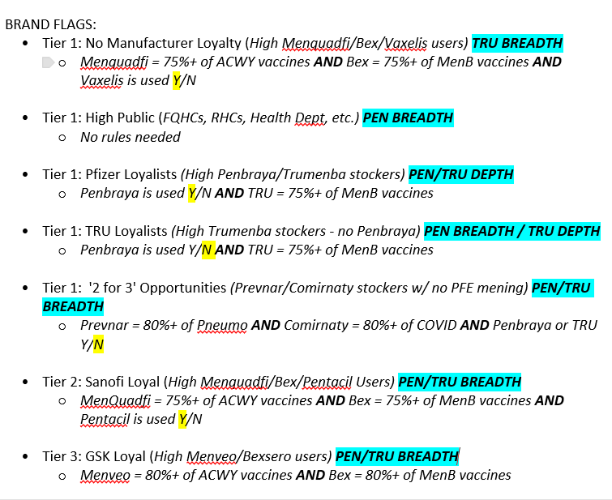

Screening Criteria
Screening Criteria
- Must treat at least 20 patients 16 to 18 years of age
- Aware of meningococcal disease caused by serogroups ACWY or meningococcal disease caused by serogroup B
- All must stock/administer MenACWY vaccines
- All must stock/administer MenB vaccines
- Must not be a low volume account (account level administration minimum of 120 doses of Men vaccines, over 20% of Men doses must be for MenB)
- At least 20% must receive at least one dose of men B vaccine; (Men ACWY + men B, men B only, men ABCWY and men B)
- Play a decision-making role in vaccine stocking decisions
- All must at least be open to vaccinating all their adolescent patients against all key meningococcal serogroups (ACWY and B)
- Mix of Loyalty groups

Section 0: Screener – HCP Demographics
[Time taken to complete this section: ~ 5 mins]
[CONSENT SCREENER]
S0.00 Thank you for agreeing to take part in this market research survey. This study aims to understand your awareness, usage and perceptions around Meningococcal Vaccines.
This study is for market research purposes only. The aim of this market research is to gain your views and is not intended to be promotional, and no one will try to sell you anything as a result of participation in the study. The survey is subject to the pharmaceutical market research industry’s code of conduct which gives you rights as a participant:
⦁Participation in this research study is voluntary.
⦁You may refuse to participate in this study, and this decision will not be held against you in any way.
⦁You have the right to withdraw from the survey at any time; however, you will only receive your honorarium upon completing the survey.
⦁This project is in accordance with all national laws protecting your personal data and with the BHBIA, MRS, ESOMAR, and EphMRA guidelines and all other relevant national codes of practice.

All information provided will remain confidential and will only be reported as group data with no identifying information.
We would like to inform you that ZoomRx is commissioning this market research project for the benefit of the sponsoring pharmaceutical company. The pharmaceutical company will not have access to any personal data associated with your responses. The pharmaceutical company will only receive aggregated results which will not identify you and will not be used to support measures or decisions regarding you. In very limited circumstances, we are obligated to disclose personal data associated with any report of adverse events mentioned by you during the survey to the pharmaceutical company, which will only use your personal data to comply with its own legal obligations.
I confirm that I have read, understood and accept the points above and am happy to proceed with the market research survey on this basis.
- Yes
- No [TERMINATE]
S0.05 If during this survey, however, you disclose information about an adverse event or product complaint, we are obligated to forward this information to the research sponsor.
Our client is required to report safety and adverse drug event information involving its products to the FDA upon becoming aware of such information. Therefore, we will forward any adverse event information immediately to the sponsor’s drug safety monitoring team. We are required to forward such information even if you have already reported it directly to the drug manufacturer or to an appropriate regulatory authority.
In such situations, unless you indicate your preference for anonymity below, we will share your contact information with the drug safety department of the study sponsor. Everything else you contribute during the study will continue to remain confidential.
Please indicate how you would like to proceed:
- I would like to proceed and protect my anonymity. Do not disclose my contact details if I share information about an adverse event or product complaint. I understand that ZoomRx is obligated to attempt to collect follow-up information from me about any adverse events I report.
- I would like to proceed and give permission to disclose my contact details. I understand that I may be contacted by the drug safety department of the research sponsor if I share information about an adverse event or product complaint.
- I do not want to proceed. Please end the survey here.
[TERMINATE IF RESPONSE = I do not want to proceed]
[IF SCREENED OUT, SHOW THE FOLLOWING TEXT]

Unfortunately, based on your answers you do not fall into a segment approved to take this survey. We will notify you of future surveys for which your segment is approved to participate. Thank you for your interest.

S0.10 Are you or any member of your immediate family currently employed in consulting, serving on permanent advisory boards, or holding an ownership position (not including stock ownership) in any of the following types of companies? Select all that apply.
[RANDOMIZE]
- Pharmaceutical company
- A medical device technology company
- A government agency
- A marketing or market research company
- A healthcare consulting firm
- None of the above [ANCHOR] [EXCLUSIVE]
[IF S0.10 <> None of the above, THANK AND TERMINATE IMMEDIATELY]
S0.20 Are you associated with any of the following? Select all that apply.
[RANDOMIZE]
- Anthem
- Blue Cross Blue Shield
- Kaiser [TERMINATE]
- Kaiser Permanente [TERMINATE]
- Permanente [TERMINATE]
- Permanente Medical Group [TERMINATE]
- United Health Care
- Yale New Haven Health System [TERMINATE]
- None of the above [ANCHOR] [EXCLUSIVE]
[IF S0.20 <> None of the above, Anthem, Blue Cross Blue Shield, United Health Care, THANK AND TERMINATE IMMEDIATELY]

S0.30 Which of the following best describes your current role? Select one.
[RANDOMIZE]
- Physician
- Nurse Practitioner or Physician Assistant
- Medical Assistant
- Nurse (LVN or RN)
- Practice Manager of a physicians’ office
- Office Manager or other member of physician’s office staff
- Pharmacist
- None of the above [ANCHOR] [EXCLUSIVE]
[IF S0.30 <> Physician, THANK AND TERMINATE IMMEDIATELY]

S0.40 What is your primary medical specialty? Select one.
- Cardiologist [TERMINATE]
- Endocrinologist [TERMINATE]
- General or Family Practice
- Internal Medicine [TERMINATE]
- Neurologist [TERMINATE]
- Pediatrician
- Other [ANCHOR] [TERMINATE]
[IF S0.40 <> General or Family Practice, Pediatrician THANK AND TERMINATE IMMEDIATELY]
S0.50 Are you board-certified or board-eligible in your specialty? Select one.
- Board-certified
- Board-eligible
- Neither
[IF S0.50 <> Board-certified, THANK AND TERMINATE IMMEDIATELY]
S0.60 Please select the primary state in which you practice.
[List state postal abbreviations in a drop-down menu in alphabetical]
[S0.60 = VT or MN, THANK AND TERMINATE IMMEDIATELY]
S0.70 How many years have you been in practice post-residency? If less than a year, please enter “1”.
______ # of years
[IF S0.70 <2 OR >35, THANK AND TERMINATE IMMEDIATELY]

S0.80 What percent of your time is spent in each of the following settings?
Practice Setting | % of Time
Private Office Setting
Public Clinic or Community Health Center
Hospital Setting (e.g., community, university)
University/Academia (e.g., instructor, researcher)
Government, VA, or Military setting
Other [ANCHOR]
Total | [FORCE SUM 100%]
[IF S0.80_SUM [Private Office Setting and Public Clinic or Community Health Center] < 60%, THANK AND TERMINATE IMMEDIATELY]

S0.90 Approximately what percentage of your professional time is spent in direct patient care?
______ % of your time
[IF S0.30 < 75%, THANK AND TERMINATE IMMEDIATELY]

S0.100 Approximately how many patients in the following age groups do you see in a typical month for routine health checks or wellness visits?
Age Groups | # of patients
0 to 10 years old
11 -15 years old
16 -18 years old
19-23 years old
24 or older
Total | [TOTAL SUM]
[IF S0.100_2 (16 – 18) < 20, THANK AND TERMINATE IMMEDIATELY]

S0.110 Which of the following best describes your involvement in the decision-making process regarding the vaccines that are stocked and administered in your practice? Please select any one.
- Primary decision maker regarding vaccine stocking and administration
- Part of a team of decision-makers regarding vaccine stocking and administration
- Provide input into the decision
- Do not provide any input into the decision
[IF S0.110 = ‘Do not provide any input into the decision’
[THANK AND TERMINATE IMMEDIATELY]
S0.120 Which of the following diseases are you aware of? Please select all that apply.
[RANDOMIZE, BUT ALWAYS KEEP 1 AND 2 TOGETHER]
- Meningococcal disease caused by serogroups ACWY
- Meningococcal disease caused by serogroup B
- HPV (human papillomavirus)
- Diphtheria, tetanus, pertussis
- Influenza
- COVID-19
- None of the above [EXCLUSIVE, ANCHOR]
[IF S0.120 ‘Meningococcal disease caused by serogroups ACWY’ OR ‘Meningococcal disease caused by serogroup B’ NOT SELECTED THANK AND TERMINATE IMMEDIATELY]
S0.130 Which of the following adolescent vaccines are stocked and administered in your practice? Please select all that apply.
[RANDOMIZE]
- Human Papillomavirus (HPV)
- Meningococcal ACWY
- Meningococcal B
- Meningococcal ABCWY (pentavalent vaccine)
- Td (tetanus and diphtheria) or Tdap (tetanus, diphtheria and pertussis)
- None of the above [EXCLUSIVE, ANCHOR] [TERMINATE]
[IF S0.130 ‘Meningococcal ACWY’ OR ‘Meningococcal B’ NOT SELECTED THANK AND TERMINATE IMMEDIATELY]
S0.140 Thinking of your entire primary practice as a whole, approximately how many doses of each of the following Meningococcal vaccines have been administered to patients in the past 12 months?
Vaccine | # of doses administered in  past 12 months
MenACWY
MenB
MenABCWY (pentavalent vaccine)
Total | [TOTAL SUM]

[IF SUM S0.140 < 120 THANK AND TERMINATE IMMEDIATELY]
[IF SUM S0.140_MenB < 20% OF TOTAL SUM THANK AND TERMINATE IMMEDIATELY]
S0.150 What percentage of your eligible patients 16 to 18 years of age will receive at least one dose of each of the following meningococcal vaccines? Please ensure the total adds up to 100%
Vaccine | % of Patients 16 to 18 Years of Age
- MenACWY only (will not receive MenB)
- MenACWY and MenB
- MenB only (will not receive MenACWY)
- MenABCWY (pentavalent vaccine)
- MenABCWY (pentavalent vaccine) and MenB
- No meningococcal vaccine
Total | [FORCE SUM 100%]
[IF SUM S0.150_ OPTION 2,4,5 < 20%, THANK AND TERMINATE IMMEDIATELY]
S0.151 Which of the following vaccines has your practice stocked in the past year? Please select all that apply.

Vaccine Type |  | Vaccine Stocked Currently
Meningococcal ACWY vaccines | Menveo (GSK)
 | MenQuadfi (Sanofi)
Meningococcal B vaccines | Bexsero (GSK)
 | Trumenba (Pfizer)
Meningococcal ABCWY (Pentavalent) Vaccines | Penbraya (Pfizer)
 | Penmenvy (GSK)
None of the above[TERMINATE]

[Programming note: Please ensure soft quotas. All respondents must select either Bexsero, Trumenba, Penbraya, or Penmenvy]

[IF S0.130 = ‘Meningococcal ACWY’]
S0.160 Approximately what proportion do each of the following brands make of the Meningococcal ACWY vaccines stocked in your practice? Please ensure the total adds up to 100%
Brand [RANDOMIZE] | % of Meningococcal ACWY Vaccines
Menveo (GSK)
MenQuadfi (Sanofi)
Total | [FORCE SUM 100%]

[IF S0.130 = ‘Meningococcal B’]
S0.170 Approximately what proportion do each of the following brands make of the Meningococcal B vaccines stocked in your practice? Please ensure the total adds up to 100%
Brand [RANDOMIZE] | % of Meningococcal B Vaccines
Bexsero (GSK)
Trumenba (Pfizer)
Total | [FORCE SUM 100%]

[IF S0.130 = ‘Meningococcal ABCWY’]
S0.160 Approximately what proportion do each of the following brands make of the Meningococcal ABCWY vaccines stocked in your practice? Please ensure the total adds up to 100%
Brand [RANDOMIZE] | % of Meningococcal ABCWY Vaccines
Penbraya (Pfizer)
Penmenvy (GSK)
Total | [FORCE SUM 100%]

S0.190 In your practice, what percent of your patients 16 to 18 years of age have each of the following types of vaccine coverage? Please ensure the total adds up to 100%
 | % of Patients 16-18
Medicaid/CHIP/Vaccines for Children (VFC)/State or Federal Funding
Private/Commercial insurance (i.e. HMO/PPO/Managed Care/Third Party Insurer)
Other (cash, no insurance, etc.)
Total | [FORCE SUM 100%]

S0.200 Approximately what percent of your pediatric patients receive vaccines through the VFC (Vaccines for Children) program?
__________ % of pediatric patients receive vaccines through the VFC program
[IF S0.190_1 > 60% OR IF S0.200 > 60% SEGMENT AS “HIGH PUBLIC”]

S0.210 Please indicate your level of agreement with each of the following statements. Please use the following scale: 1 = Strongly disagree, 3 = Neither agree not disagree, 5 = Strongly agree
Statement [RANDOMIZE] | Options
If I could, I would vaccinate all of my adolescent patients against the five key meningococcal serogroups (ACWY and B) | Rating Scale [1-5]
If a parent or adolescent patient resists vaccination against invasive meningococcal disease (IMD), I try hard to convince them to accept the vaccination
Contracting, rebating, and discounting are barriers to adoption of a new vaccine by a different manufacturer from the one(s) with whom my practice currently contracts
With a decrease in wellness visits among my older adolescent patients, it is harder for me to ensure they are fully protected against the five key meningococcal serogroups (ACWY and B)
[IF S0.210_ OPTION 1 RATING NOT ‘3’,’4’,’5’ THANK AND TERMINATE IMMEDIATELY]
[IF S0.80_2 > 0]
S0.220 Which one best describes the public clinic or community center in which you practice most? Select one.
- Federally Qualified Health Center (FQHC) funded by the HRSA Health Center Program
- Other clinic or community health center (not funded by HRSA Health Center Program)
S0.230 Is the practice or clinic at which you spend the majority of your time part of an Integrated Delivery Network (IDN)? Select one.
- Yes
- No
S0.240 In which setting is your practice currently located? Select one.
- Suburban
- Urban
- Rural

BP IN. Thank you for completing the screener. You are now qualified to take the survey deep-dive
BP OUT. We are sorry, Doctor. Based on your answers, you fall into a group for which we already have enough participants. Thank you for your interest in participating in the research.

Section 1: Disease State Awareness and Urgency to Discuss Vaccines
[Time taken to complete this section: ~ 1 min]
BP 1.00 The next few questions will focus on infectious diseases that impact adolescents and young adults.
[INTERNAL NOTE: KPI METRIC]
Q1.10 How knowledgeable do you feel when it comes to the following diseases? Please use the following scale: 1 = Not at all knowledgeable, 3 Somewhat Knowledgeable, 5 = Extremely Knowledgeable
Disease [RANDOMIZE, BUT ALWAYS KEEP OPTION_1 AND OPTION_2 TOGETHER] | Options
Meningococcal disease caused by serogroups ACWY | Rating Scale [1-5]
Meningococcal disease caused by serogroup B
HPV (human papillomavirus)
Diphtheria, tetanus, pertussis
Influenza
COVID-19

[INTERNAL NOTE: KPI METRIC]
Q1.20 How much of a priority is discussing each of these diseases during conversations with your 16-18 year old patients and/or their caregivers? Please use the following scale: 1 = Not at all a Priority, 3 = Neutral, 5 = Top Priority
Disease [RANDOMIZE, BUT ALWAYS KEEP OPTION_1 AND OPTION_2 TOGETHER] | Options
Meningococcal disease caused by serogroups ACWY | Rating Scale [1-5]
Meningococcal disease caused by serogroup B
HPV (human papillomavirus)
Diphtheria, tetanus, pertussis
Influenza
COVID-19

Section 2: Current Vaccine Preferences & Attitudes
[Time taken to complete this section: ~ 6 mins]
BP 2.00 The next series of questions will focus on meningococcal disease.

[INTERNAL NOTE: KPI METRIC]
Q2.10 What manufacturers are you aware of, if any, that have a Meningococcal vaccine under development or already launched a Meningococcal vaccine?
[VOICE RESPONSE]
[INTERNAL NOTE: KPI METRIC]
Q2.14 In the text boxes below please type vaccines you are aware of, if any, that are in development or already launched for the prevention of Meningococcal disease.
[VOICE RESPONSE]
Q2.15 To confirm, are you aware of any pentavalent Meningococcal vaccine(s) that cover five serogroups A,B,C,W,Y?
- Yes
- No
[IF Q2.15 = ‘Yes’]
Q2.20 Please include any details you know such as vaccine name(s), manufacturer(s), product attributes(s), etc. for each pentavalent Meningococcal vaccine(s) that cover five serogroups A,B,C,W,Y. Please be as specific as you can.
[VOICE RESPONSE]
Q2.25 How familiar are you with the following Meningococcal vaccines? Please use the following scale: 1 = Never heard of, 2 = Heard of but just know the name, 3 = Heard of but do not know much about, 4 = Somewhat familiar, 5 = Extremely familiar
Brand [RANDOMIZE, BUT ALWAYS KEEP OPTION_1 AND OPTION_2 TOGETHER, OPTION_3 AND OPTION_4 TOGETHER] | Options
Menveo | Rating Scale [1-5]
MenQuadfi
Trumenba
Bexsero
Penbraya
Penmenvy

Q2.30 What percent of your total stock of Meningococcal vaccines does each brand represent? Your responses must sum to 100%.
Brand  [SHOW PRODUCT IF FAMILIAR IN Q2.25=2-5] | % of Meningococcal Vaccines
Menveo
MenQuadfi
Trumenba
Bexsero
Penbraya
Penmenvy
Total | [FORCE SUM 100%]

Q2.32 To the best of your knowledge, have you noticed whether any of the following factors have impacted meningococcal vaccine rates among your patients 16 and older:
[RANDOMIZE OPTIONS] | % of Meningococcal Vaccines
Recent outbreaks and cases | 1 = Extremely (+15%) Decrease  2 = Moderate (5-10%) Decrease  3 = Slight (>5%) Decrease  4 = No Change  5 = Slight (>5%) Increase  6 = Moderate (5-10%) Increase  7 = Extreme (+15%) Increase
Change in college or university policies
Changes in public health messaging
Changes in vaccine hesitancy among patients
Insurance / cost factors
Wellness visits

[IF Q2.15 = ‘Yes’ AND Q2.30_Penbraya > 0] OR Q2_30_Penmenvy>0 AND MDs aware of both MenABCWY and Penbraya OR Penmenvy)

Q2.35 In the past 6 months, for what percent of your patients 16-18 years old who were eligible for both MenACWY and 1st dose of MenB vaccinations at the same visit did you recommend two separate vaccines vs. one MenABCWY pentavalent vaccine? Your responses must sum to 100%.
Vaccine | % of Meningococcal Vaccines
MenACWY + MenB separate vaccines
MenABCWY pentavalent vaccine
Penmenvy
Total | [FORCE SUM 100%]

[IF Q2.35_MenABCWY pentavalent vaccine > 0%]
Q2.40 After recommending the MenABCWY pentavalent vaccine to your patients 16-18 years old who were eligible for both MenACWY and MenB vaccinations in the same visit, what percent of the time did the following occur? Your responses must sum to 100%.
Statement | % of Time
Patient/Caregiver accepted the MenABCWY pentavalent vaccine without question
Patient/Caregiver initially questioned/pushed back on the MenABCWY pentavalent vaccine, but ultimately received it
Patient/Caregiver refused the MenABCWY pentavalent vaccine and received separate MenACWY and MenB vaccines instead
Patient/Caregiver refused the MenABCWY pentavalent vaccine and did not receive any meningococcal vaccine
Total | [FORCE SUM 100%]

Q2.41. How well equipped do you feel to handle patient questions/objections?
Please use a scale of 1-7, where 1 indicates “I feel very under-equipped” and 7 indicates “I feel perfectly well equipped”
[IF Q2.15 = ‘Yes’ AND Q2.30_Penbraya > 0] //MDs aware of both MenABCWY and Penbraya)
OR IF Q2.15 = ‘Yes’ AND Q2.30_Penmenvy>0 // MDs aware of Penmenvy]
Q2.45 Are you proactively discussing the MenABCWY pentavalent vaccine with caregivers and eligible patients 16-18 years of age? Select one.
- Yes
- No
[IF Q2.45 = ‘Yes’]
Q2.50 What is being discussed about the MenABCWY pentavalent vaccine with caregivers and eligible patients 16-18 years of age? Please be as specific as you can.
[VOICE RESPONSE]
[DYNAMIC DIALOGUES – AI BASED TEXTUAL FOLLOW-UP QUESTION WILL BE ASKED (Two Questions)]

Q2.55 To the best of your knowledge, which of the following statements are part of the CDC ACIP’s recommendation(s) for healthy adolescents and young adults for vaccination against Meningococcal disease? Select all that apply.
[RANDOMIZE]
- MenABCWY vaccine may be used when both MenACWY and MenB are indicated at the same visit
- It is recommended that patients receive 2 doses for MenACWY vaccination
- It is recommended that patients receive 2 doses for MenB vaccination
- MenB is recommended based on shared clinical decision making to be administered to adolescents ages 16-23 years, with preferred age of 16-18
- Administration of MenACWY and MenB can be indicated in the same visit
- When using a MenABCWY pentavalent vaccine to protect against MenB, a dose of MenB vaccine from the same manufacturer should follow 6 months later
- Unsure [EXCLUSIVE, ANCHOR]
Q2.60 Are you aware of CDC updates to meningococcal vaccination recommendations as of January 2026?
- Yes
- No

[IF Q2.60 = ‘Yes’]
Q2.65 Please describe what you know about the changes to the official CDC recommendations for the meningococcal vaccine schedule. Please be as detailed as possible.
[VOICE RESPONSE]

[IF Q2.60 = ‘Yes’]
Q2.65 Which of the following changes to the meningococcal (meningitis) vaccine immunization schedule, if any, are you aware of? Select all that apply.
- The menACWY vaccine is no longer a "universal routine" recommendation for all healthy adolescents.
- MenACWY vaccine is now under shared clinical decision-making (SCDM): Decisions for healthy children now rely on a case-by-case discussion between healthcare providers and parents.
- For high-risk groups, the menACWY vaccine remains fully recommended
- None of the above [EXCLUSIVE OPTION]

[IF Q2.60 = ‘Yes’]
Q2.67 Please describe how your vaccination practices will change or will not change in response to the CDC updates to meningococcal vaccination recommendations from January 2026. Please be as detailed as possible.
[VOICE RESPONSE]

Section 3: Penbraya Branded Evaluation
[Time taken to complete this section: ~ 8 mins]
BP 3.00 Please review the following information for Penbraya (Pfizer's 5-in-1 Pentavalent vaccine for MenABCWY), a recently approved vaccine, along with a graphic detailing an all-in-one kit (with vial-adapter) for needle-free reconstitution of Penbraya (Pfizer's 5-in-1 Pentavalent vaccine for MenABCWY).
Note: A link to this information will be available to review as you answer questions that follow, in case you need to refer back to the information.
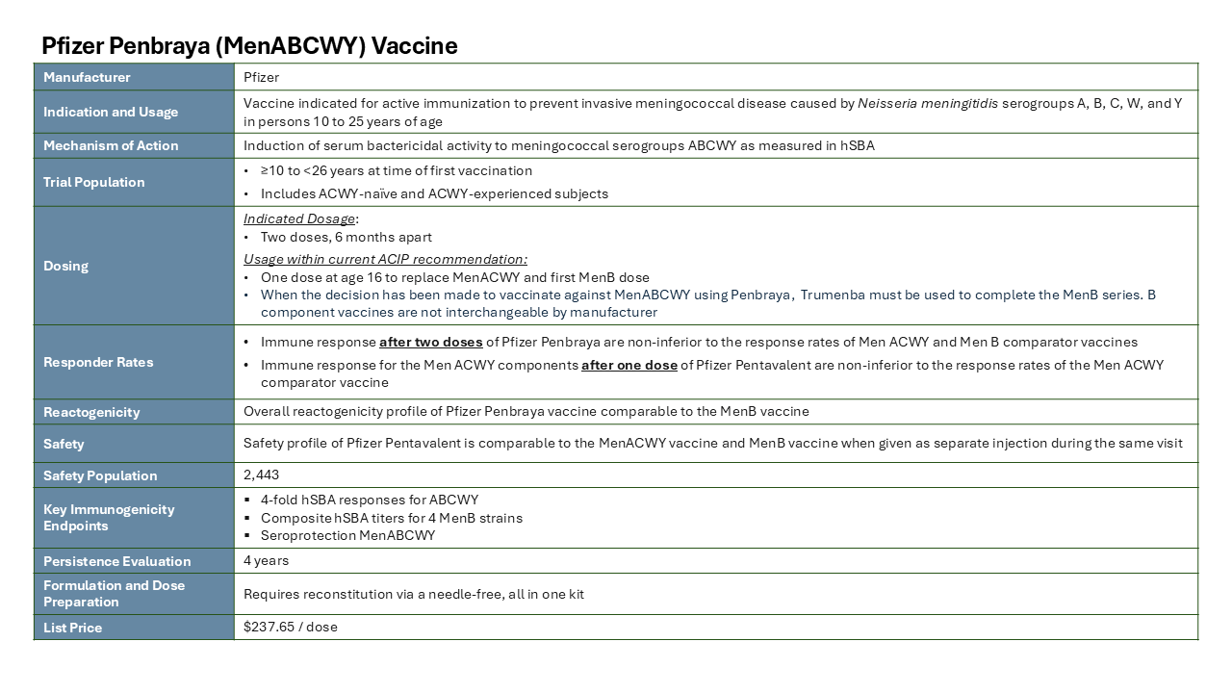

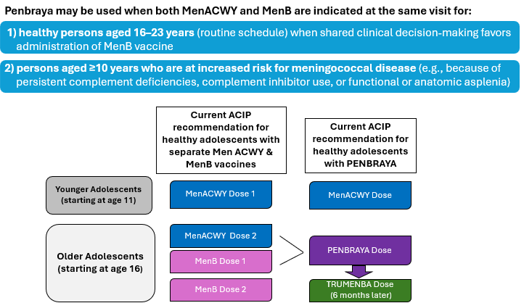

BP 3.10 When answering the following questions about Penbraya (Pfizer's 5-in-1 Pentavalent vaccine for MenABCWY), please consider that:
- Recommendation for Penbraya (Pfizer's 5-in-1 Pentavalent vaccine for MenABCWY) was published in the CDC’s MMWR on April 18, 2024.
- Penbraya (Pfizer's 5-in-1 Pentavalent vaccine for MenABCWY) was added to the Vaccine for Children (VFC) program in April 2024.

[IF Q2.30_Penbraya = 0%] // PENBRAYA NON-STOCKERS
Q2.65 How likely are you to stock Penbraya (Pfizer's 5-in-1 Pentavalent vaccine for MenABCWY) in your practice? Please consider your total stock of vaccines and existing contracts. Select one.
1 = Not at all Likely / 7 = Extremely Likely
[1-7 RATING SCALE]

[IF Q2.30_Penbraya = 0% AND Q2.65 > 1] // PENBRAYA NON-STOCKERS
Q2.70 How long would it take for you to first recommend / stock Penbraya (Pfizer's 5-in-1 Pentavalent vaccine for MenABCWY) in your practice? Select one.
- Less than 1 month
- 1 month to less than 3 months
- 3 months to less than 6 months
- 6 months to less than 9 months
- 9 months to less than 12 months
- More than 12 months
- Unsure

Q2.75 How long would it take for you to fully incorporate Penbraya (Pfizer's 5-in-1 Pentavalent vaccine for MenABCWY) in your practice? Select one.
- Less than 1 month
- 1 month to less than 3 months
- 3 months to less than 6 months
- 6 months to less than 9 months
- 9 months to less than 12 months
- More than 12 months
- Already fully incorporated [SHOW OPTION IF Q2.30_Penbraya > 0] //STOCKERS ONLY
- Unsure

Q2.80 In three months from now, what percent of your total stock of Meningococcal vaccines do you anticipate each brand will represent? As a reference, your current stock responses are displayed. Your responses must sum to 100%.
Note: MenB vaccines are not interchangeable, so Penbraya must be followed by Trumenba [IF C5r6 =/ 1: and Penmenvy must be followed by Bexsero].

Brand  [SHOW PRODUCT IF FAMILIAR IN Q2.25=2-5] | Current Stock  [PIPE IN “% of Meningococcal Vaccines” FROM Q2.30] | Future Stock  in 3 months from now
Menveo
MenQuadfi
Trumenba
Bexsero
Penbraya
[SHOW TO ALL]
Penmenvy
Total |  | [FORCE SUM 100%]

Q2.85 How likely are you to recommend Penbraya (Pfizer's 5-in-1 Pentavalent vaccine for MenABCWY) for eligible 16-18 year old patients? Select one.
1 = Not at all Likely / 7 = Extremely Likely
[1-7 RATING SCALE]

[IF Q2.85 = 6, 7]
Q2.90a Why are you highly likely to recommend Penbraya (Pfizer's 5-in-1 Pentavalent vaccine for MenABCWY) for your 16-18 year old patients? Please be as specific as you can.
[VOICE RESPONSE]
[DYNAMIC DIALOGUES – AI BASED TEXTUAL FOLLOW-UP QUESTION WILL BE ASKED (One Question)]

[IF Q2.85 <> 6 OR 7]
Q2.90b Why are you less likely to recommend Penbraya (Pfizer's 5-in-1 Pentavalent vaccine for MenABCWY) for your 16-18 year old patients? Please be as specific as you can.
[VOICE RESPONSE]
[DYNAMIC DIALOGUES – AI BASED TEXTUAL FOLLOW-UP QUESTION WILL BE ASKED (One Question)]

Q2.95 In three months from now, for what percent of your patients 16-18 years old who are eligible for both MenACWY and 1st dose of MenB vaccinations at the same visit do you anticipate recommending two separate vaccines vs. Penbraya (Pfizer's 5-in-1 Pentavalent vaccine for MenABCWY)? As a reference, your past responses are displayed. Your responses must sum to 100%.
Vaccine | % 16-18 year old Recommendations
 | Past Month  [PIPE IN “% of Meningococcal Vaccines” FROM Q2.35] | 3 months from now
MenACWY + MenB separate vaccines
MenABCWY pentavalent vaccine
Total |  | [FORCE SUM 100%]

Q2.100 How familiar are you with the dosing schedule for Penbraya (Pfizer's 5-in-1 Pentavalent vaccine for MenABCWY)? Select one.
1 = Not at all Likely / 7 = Extremely Likely
[1-7 RATING SCALE]
Q2.100 How clear is it that when vaccinating against MenABCWY using Penbraya, Trumenba must be used 6 months later following Penbraya to complete the MenB series, as MenB vaccines are not interchangeable by manufacturer? Select one.
1 = Not at all clear / 7 = Extremely clear
[1-7 RATING SCALE]
[IF S0.170_ Trumenba = 0] // Trumenba Non Stockers
Q2.105 Given the recommended dosing schedule with Penbraya, how likely are you to stock Trumenba (Pfizer's Meningococcal Group B Vaccine) in your practice? Please consider your total stock of vaccines and existing contracts. Select one.
1 = Not at all Likely / 7 = Extremely Likely
[1-7 RATING SCALE]


[IF S0.170_ Bexsero > 0] // Bexsero Stockers
Q2.110 Given the recommended dosing schedule with Penbraya, how likely are you to continue stocking Bexsero (GSK's Meningococcal Group B Vaccine) in your practice? Please consider your total stock of vaccines and existing contracts. Select one.
1 = Not at all Likely / 7 = Extremely Likely
[1-7 RATING SCALE]

Q2.115 Are you aware that Bexsero now has the same two-dose schedule as Trumenba (0 and 6 months) in their prescribing information? The label for Bexsero no longer includes a 2-dose schedule of 0 and 1+ months. Select one
- Yes
- No

[IF S0.170_ Trumenba = 0] // Trumenba Non Stockers
Q2.120 Considering that Bexsero now has the same two-dose schedule as Trumenba (0 and 6 months) in their prescribing information, now how likely are you to reconsider your current MenB vaccine given this additional information? Please consider your total stock of vaccines and existing contracts. Select one.
1 = Not at all Likely to Reconsider / 7 = Extremely Likely to Reconsider
[1-7 RATING SCALE]

[IF Q2.120 = 1-3]
Q2.125 Why does the recent label change to a two-dose schedule for Bexsero (0 and 6 months) not strongly impact your decision-making? Select all that apply.
- I’m concerned about losing discounts on other GSK products
- Switching to a new MenB vaccine would cause too much disruption for my practice
- My PBG or GPO does not offer Trumenba
- Trumenba contract terms available to me are not as competitive as for Bexsero
- Despite the label change, I don’t see a compelling reason to switch my preferred MenB vaccine
- Other (please specify: _______)

[ASK TO ALL]
Q2.130 In your opinion, which meningococcal B vaccine is more clinically advantageous? Select one.
- 1 = Major clinical advantage for Bexsero
- 2 = Slight clinical advantage for Bexsero
- 3 = Clinically interchangeable
- 4 = Slight clinical advantage for Trumenba
- 5 = Major clinical advantage for Trumenba

[ASK TO ALL]
Q2.135 How likely are you to revisit your overall approach to meningococcal disease protection, i.e., consider Penbraya + Trumenba vs. separate MenACWY vs. MenB vaccines? Select one.
1 = Not at all Likely / 7 = Extremely Likely
[1-7 RATING SCALE]
Q2.135 What information or data would encourage you to revisit your overall approach to meningococcal disease protection and stocking decisions? Please be specific.
[VOICE RESPONSE]
[DYNAMIC DIALOGUES – AI BASED TEXTUAL FOLLOW-UP QUESTION WILL BE ASKED (One Question)]

Q2.140 In three months from now, what percent of your total stock of Meningococcal vaccines do you anticipate each brand will represent, given Penbraya and Trumenba dosing schedule and that Bexsero now has the same dosing schedule as Trumenba?
As a reference, your earlier responses are displayed prior to reinforcement of the considerations above. Your responses must sum to 100%.
Note: MenB vaccines are not interchangeable, so Penbraya must be followed by Trumenba [IF C5r6 =/ 1: and Penmenvy must be followed by Bexsero].
Brand  [SHOW PRODUCT IF FAMILIAR IN Q2.25=2-5] | Current Stock  [PIPE IN “% of Future Stock  in 3 months from now” FROM Q2.80] | Future Stock  in 3 months from now
Menveo
MenQuadfi
Trumenba
Bexsero
Penbraya
[SHOW TO ALL]
Penmenvy
Total |  | [FORCE SUM 100%]

Q2.145 Excluding financial considerations and potential vaccine platform changes, what are all the reasons you may not administer Penbraya (Meningococcal Groups A, B, C, W, and Y vaccine) to eligible patients? Record your response below, being as detailed as possible.
[VOICE RESPONSE]
BP 3.20 Please again consider the ACIP recommendation for Penbraya (Pfizer's 5-in-1 Pentavalent vaccine for MenABCWY) – shown again here for reference:



Q2.155 Compared to your practice's current meningococcal vaccination protocols, would you say the ACIP recommendation requiring Penbraya (Pfizer's 5-in-1 Pentavalent vaccine for MenABCWY) be followed by the same manufacturer (in this case) a TRUMENBA dose, 6 months later is…? Select one.
- Easier than the current meningococcal vaccination protocols
- Neither easier nor more difficult than the current meningococcal vaccination protocols
- More difficult than the current meningococcal vaccination protocols

Q2.160 Which of the following Meningococcal vaccine brands were requested by caregivers or patients 16-18 years of age in the past 6 months? Select all that apply, or none.
[SHOW PRODUCT IF FAMILIAR IN Q2.25=2-5]
- Menveo
- MenQuadfi
- Trumenba
- Bexsero
- Penbraya
- None of the above [EXCLUSIVE, ANCHOR]

Q2.165 What percent of the time did you administer each brand when requested by caregivers or patients 16-18 years of age? Enter a whole number between 0-100 for each brand.
Brand  [SHOW PRODUCT IF SELECTED IN Q2.160] | % of Time
Menveo | ___ %
MenQuadfi | ___ %
Trumenba | ___ %
Bexsero | ___ %
Penbraya | ___ %

Q2.170 Please indicate the level of comfort you have administering or recommending each vaccine to patients 16-18 years of age. Select one for each row.
Brand
[SHOW PRODUCT IF FAMILIAR IN Q2.25=2-5]
Menveo | 1 = Not at all Comfortable / 7 = Extremely Comfortable  [1-7 RATING SCALE]
MenQuadfi
Trumenba
Bexsero
Penbraya [SHOW TO ALL]
Penmenvy

Section 4: Barriers to Prescribing
[Time taken to complete this section: ~ 3 mins]
[IF Q2.30_Penbraya > 0%] // PENBRAYA STOCKERS
Q4.05 Please describe in as much details as possible, the challenges that you experienced with stocking Penbraya (Pfizer's 5-in-1 Pentavalent vaccine for MenABCWY).
[VOICE RESPONSE]

Q4.10a Which of the following challenges did you experience with stocking Penbraya (Pfizer's 5-in-1 Pentavalent vaccine for MenABCWY)? Select all that apply.
 | Storage [NEED NOT SHOW]
1 | Lack of refrigerator storage space | □
2 | Vaccine package size | □
 | Scheduling [NEED NOT SHOW]
3 | Difficulty in scheduling patients for their initial/first dose | □
4 | Difficulty in scheduling patients for their second/booster dose | □
5 | Having to administer Trumenba 6 months after patient receives Penbraya | □
 | Training [NEED NOT SHOW]
6 | Need to train staff on Penbraya vaccine schedule | □
7 | Need to train staff on reconstitution process for Penbraya | □
 | Stocking [NEED NOT SHOW]
8 | ACIP recommendation requires stocking of multiple vaccine brands (up to 3) which brings added operational complexity | □
9 | ACIP recommendation requires stocking of multiple vaccine brands (up to 3) which may increase initial inventory carrying costs | □
10 | Stocking Pfizer’s Pentavalent requires the need to stock Trumenba | □
 | Contracting/Costs [NEED NOT SHOW]
11 | Losing rebates/discounts for vaccine brands my practice originally stocked | □
12 | Changes to existing and long-standing supplier contracts/relationships | □
13 | Higher discount or more favorable contract terms on competitor vaccines vs. Pfizer vaccines | □
14 | Increased difficulty of measuring market share-based performance if engaged in a performance-based contract for discounts on other vaccine brands | □
15 | ONLY SHOW NON-STOCKERS [IF Q2.30_Penbraya = 0%] // PENBRAYA NON-STOCKERS]: Increased risk of provider confusion as to which meningococcal vaccine to administer | □
16 | Other (Please specify) [ANCHOR] | □
17 | No barriers to stocking Penbraya [EXCLUSIVE, ANCHOR] | □

[IF Q2.30_Penbraya = 0%] // PENBRAYA NON-STOCKERS
Q4.10b Which of the following do you anticipate being a challenge to stocking Penbraya (Pfizer's 5-in-1 Pentavalent vaccine for MenABCWY)? Select all that apply.
Statement
[SAME LIST AS Q4.10a] | Select all that apply

[IF Q2.30_Penbraya = 0%] // PENBRAYA NON-STOCKERS
Q4.15 How much do you agree or disagree with the following statement:
1 = Disagree Strongly / 7 = Agree Strongly
[1-7 RATING SCALE]
Statements | Level of Agreement
I am confident in being reimbursed by insurers for administering Penbraya (Meningococcal Groups A, B, C, W, and Y vaccine) to appropriate patients | [1 – 7]

[IF Q2.30_Penbraya = 0% AND Q4.15 < 6]
Q4.20 Which of the following has an impact on your confidence in insurance coverage and reimbursement for Penbraya? Select all that apply.
[RANDOMIZE]
- Unclear insurance coverage policies
- Patient out of pocket costs
- Challenging to determine patient insurance coverage
- Need for prior authorization unclear
- Reimbursement amount variable unknown prior to purchase
- Lack of Medicaid insurance coverage
- Reimbursement amount not enough
- Lack of commercial insurance coverage
- Billing/coding requirement unclear
- Reimbursement differs from other vaccines
- Reimbursement takes too long
- Other (Please specify) [ANCHOR]

Section 5: Competitive Evaluation
[Time taken to complete this section: ~ 6 mins]
BP 5.00 Please review the following information for Penmenvy (GSK’s 5-in-1 Pentavalent vaccine for MenABCWY), a recently approved vaccine. Also assume it’s available for use, added to the VFC program, and will be fully reimbursed per ACIP recommendations.
Note: A link to this information will be available to review as you answer questions that follow, in case you need to refer back to the information.
[SHOW TPP. INCLUDE 2 TPP LINKS THROUGHOUT THIS SECTION: PENBRAYA AND Penmenvy TPPs]
TPP:
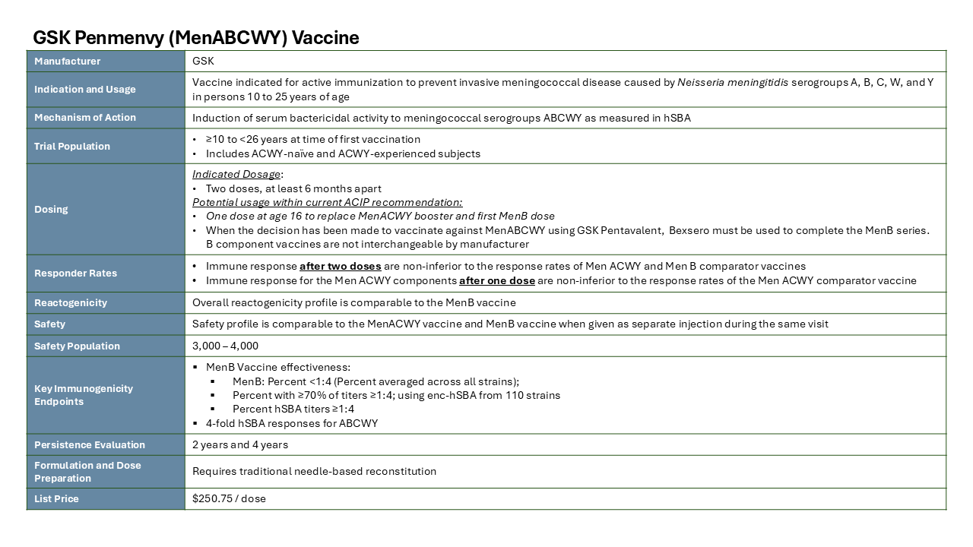
Note: Confidential. Hypothetical profile for market research purposes only. No such product has been approved or marketed in the United States.
As a reminder, assume Penmenvy (GSK’s 5-in-1 Pentavalent vaccine for MenABCWY) is available for use, added to the VFC program, and will be fully reimbursed per ACIP recommendations, as you answer the questions that follow.
Q5.10 How likely are you to stock Penmenvy (GSK’s 5-in-1 Pentavalent vaccine for MenABCWY) in your practice, assuming cost and financial factors are not a barrier to use? Select one.
1 = Not at all Likely/ 7 = Extremely Likely
[1-7 RATING SCALE]
[IF Q5.10 > 1]
Q5.15 How long would it take for you to first recommend / stock Penmenvy (GSK’s 5-in-1 Pentavalent vaccine for MenABCWY) in your practice? Select one.
- Less than 1 month
- 1 month to less than 3 months
- 3 months to less than 6 months
- 6 months to less than 9 months
- 9 months to less than 12 months
- More than 12 months
- Unsure
[IF Q5.10 > 1]
Q5.20 How long would it take for you to fully incorporate Penmenvy (GSK’s 5-in-1 Pentavalent vaccine for MenABCWY) in your practice, after MMWR publication and inclusion in the VFC program? Select one.
- Less than 1 month
- 1 month to less than 3 months
- 3 months to less than 6 months
- 6 months to less than 9 months
- 9 months to less than 12 months
- More than 12 months
- Unsure
Q5.25 How likely are you to recommend Penmenvy (GSK’s 5-in-1 Pentavalent vaccine for MenABCWY) for your 16–18-year-old patients? Select one.
1 = Not at all Likely/ 7 = Extremely Likely
[1-7 RATING SCALE]

[IF Q5.25 >5]
Q5.30a Why are you likely to recommend Penmenvy (GSK’s 5-in-1 Pentavalent vaccine for MenABCWY) for your 16-18 year old patients? Please be as specific as you can.
[VOICE RESPONSE]

[IF Q5.25 <6]
Q5.30b Why are you not likely to recommend Penmenvy (GSK’s 5-in-1 Pentavalent vaccine for MenABCWY) for your 16-18 year old patients? Please be as specific as you can.
[VOICE RESPONSE]

Q5.35 How much of an improvement do you consider Penmenvy (GSK’s 5-in-1 Pentavalent vaccine for MenABCWY) to be over the current meningococcal vaccinations? Select one for each row.
1 = No Improvement at all/ 7 = Significant Improvement
[1-7 RATING SCALE]
Vaccine | Level of Improvement
MenACWY + MenB vaccines | [1 – 7]
Penbraya | [1 – 7]

Q5.40 Given what you know about both pentavalent vaccines for MenABCWY (Penbraya and Penmenvy), how likely are you to recommend one vaccine over the other? Select one.
- 1 = Significantly more likely to recommend Penmenvy
- 2 = Somewhat more likely to recommend Penmenvy
- 3 = Not likely to recommend one over the other
- 4 = Somewhat more likely to recommend Penbraya
- 5 = Significantly more likely to recommend Penbraya

Q5.45 Why are you [PIPE IN RESPONSE FROM Q5.40]? Please be as specific as you can.
[VOICE RESPONSE]

Q5.55 If given a choice between two pentavalent vaccines for MenABCWY, how important would each of the following attributes be to your selection of a vaccine for patients 16-18 years of age? Select one rating for each attribute.
1 = Not at all Important / 7 = Extremely Important
[1-7 RATING SCALE]
Attributes [RANDOMIZE] | Level of Importance
Included in the Vaccine for Children (VFC) program | 1 = Not at all Important/ 7 = Extremely Important  [1-7 RATING SCALE]
Clinically demonstrated coverage against a panel of diverse MenB strains
Manufacturer offers a full meningococcal portfolio of vaccines
Needle-free reconstitution
High familiarity with the vaccine components
Vaccine is supported by robust clinical development data
Built on well-established meningococcal vaccines
Positive net acquisition cost implications / lower list price
Manufacturer is a trusted partner in pediatric and adolescent vaccines
Manufacturer offers contracting that supports my use
Aligns with the manufacturer I use most for vaccine purchases

Q5.60 To what extent do you associate each MenABCWY pentavalent vaccine with the attribute below? Base your response on a 7-point scale where 1=Not at all Associated and 7=Extremely Associated. Select one per row.
1 = Not at all Associated / 7 = Extremely Associated
[1-7 RATING SCALE]
Brand | Attribute  [1-7 RATING SCALE]
Penbraya | [LIST ATTRIBUTES FROM Q5.55]
Penmenvy
[DO NOT SHOW FOR ATTRIBUTES 1, 3, 9, 10]

Q5.65 Now please consider again your future stock. In three months from now, what percent of your total stock of Meningococcal vaccines do you anticipate each brand will represent, given Penbraya and Trumenba dosing schedule and that Bexsero now has the same dosing schedule as Trumenba?
As a reference, your earlier responses are displayed prior to reinforcement of the considerations above. Your responses must sum to 100%.
Note: MenB vaccines are not interchangeable, so Penbraya must be followed by Trumenba and Penmenvy must be followed by Bexsero.

Brand  [SHOW PRODUCT IF FAMILIAR IN Q2.25=2-5] | Current Stock  [PIPE IN “% of Meningococcal Vaccines” FROM Q2.140] | Future Stock  in 3 months from now
Menveo
MenQuadfi
Trumenba
Bexsero
Penbraya
[SHOW TO ALL]
Penmenvy
[SHOW TO ALL]
Total |  | [FORCE SUM 100%]

[INTERNAL NOTE: Section on Vaccine Manufacturers & Demographics sections removed from Pilot wave of ATU]

